

FUFO_VP
Software Architecture

Project Code: FUFO_VP
Document Code: FUFO_VP_SAD– v1.0.1

Ha Noi, March 10th , 2012

Record of change

*A - Added M - Modified D - Deleted
Effective Date | Changed Items | A*  M, D | Change Description | New Version
2012/03/10 | Introduction | A | Add introduction | 1.0.1

SIGNATURE PAGE

ORIGINATOR: NguyenLK March 10th, 2012
Team Leader

REVIEWERS: <Name> <Date>
<Position>

<Name, if it’s needed> <Date>
<Position>

APPROVAL: <Name> <Date>
<Position>
TABLE OF CONTENTS
1 Introduction 3
1.1 Purpose 3
1.2 Scope 3
1.3 Definitions, Acronyms and Abbreviations 3
1.4 References 3
1.5 Overview 3
2 Architectural Representation 3
3 Architectural Goals and Constraints 3
4 Use-Case View 3
4.1 Use-Case Realizations 3
5 Logical View 3
5.1 Overview 3
5.2 Architecturally Significant Design Packages 3
6 Process View 3
7 Deployment View 3
8 Implementation View 3
8.1 Overview 3
8.2 Layers 3
9 Data View (optional) 3
10 Size and Performance 3
11 Quality 3
12 Other Considerations 3

Introduction

Purpose
This document helps developers understand more clearly about FUFO system. It is also used by customer to review all functions more evidently to prevent misunderstanding of developers about system. Moreover, it is used for integration test, all functions have to map with this document.

Scope
This document describes architectural design guidelines and requirements for the VP module. This includes user functional and non-functional requirements, business use-cases, and software layering approach, technology and software requirements, and external interfaces to other systems.

Definitions, Acronyms and Abbreviations
Acronym | Definition | Note
SAD | Software Architectural Document
AOP | Application on phone
AOC | Application on computer
FUFO | FPT University Flying Object | Controlled by AOC through AOP

References
N/A

Overview
The content of this SRS is organized as follow:
- Section 1 is a general introduction to this document.
- Section 2 is an architectural representation to describe the general factors that affect the products and its requirements.
- Section 3 is an architectural goal and constraints.
- Section 4 is use – case view.
- Section 5 is logical view
- Section 6 is process view
- Section 7 is implementation view
- Section 8 is data view
- Section 9 is size and performance
- Section 10 is quality
- Section 11 is other consideration

Architectural Representation
This VP system uses architect client – server architecture to communicate between AOP and AOC. It uses TCP/IP protocol to control command and status between AOP and AOC to ensure the transferring not error. It also uses UDP to stream video from AOP to AOC to improve speed of transferring.
It also uses component-based architecture to split this system to 3 components: Status control, command control and video control.
We will describe more clearly on following section.

Architectural Goals and Constraints
N/A

Use-Case View

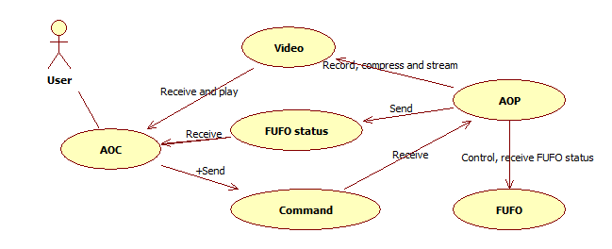
Figure 1 : Use – Case diagram for VP

Use-Case Realizations
The VP system contains two app on computer and Android phone. User will control FUFO via AOC‘s screen. AOC will control command from user to send to AOP and receive video and status from AOP to show out screen.

Logical View

Overview

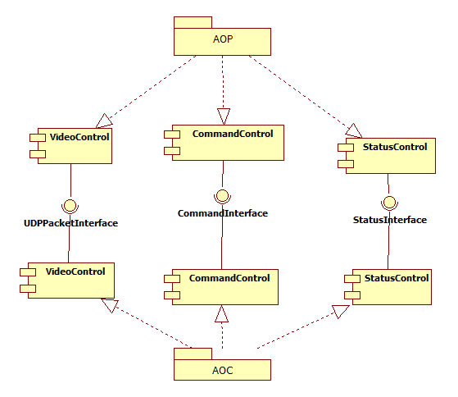
Figure 2: Component diagram for VP system
The VP system contains three components:
- Video Control: use to control streaming video from AOP to AOC. It uses camera on Android phone to record video and send frames to AOC by UDP protocol.
- Command Control: use to control command from AOC to AOP. It receives commands from users via keyboard and sends these commands to AOP through TCP protocol. This AOP is also send commands to FUFO via Bluetooth why receiving commands from AOC.
- Status Control: use to control status sent from FUFO to AOP via Bluetooth and from AOP to AOC via TCP protocol. These statuses will be shown on user screen.
These components on AOP application and on AOC application are classes can work independent with other components. Component on two applications communicate together by their interface as Figure 2.
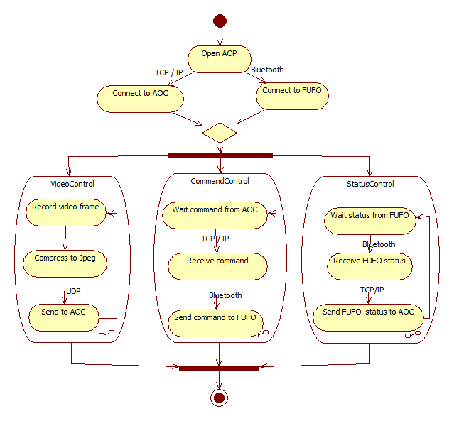
Figure 3 : Activity Diagram for AOP
Three components on AOP application is run by three threads work parallel and independent.
- Control video thread: use to control video. After record video frame from camera phone, it will compress this frame to JPEG type, packages it, uses Datagram Socket to send to AOC, then return record other video frame.
- Control command thread: use to control command. It waits commands from AOC via TCP protocol and sends these commands to FUFO via Bluetooth. It uses same socket with thread control status.
- Control status thread: use to control status. It waits status from FUFO via Bluetooth and sends to AOC via TCP protocol.
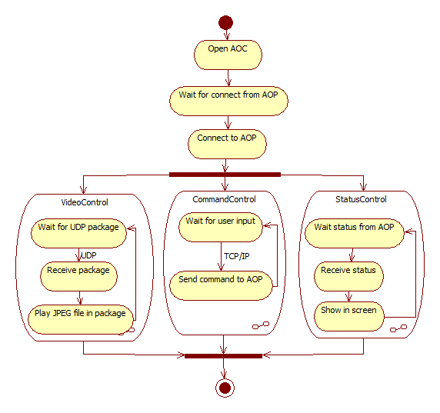
Figure 4 : Activity diagram for AOC
Three components on AOC application is run by three threads work parallel and independent.
- Control video thread: use to control video. It waits UDP package from AOP, then gets picture frame from package and show it on screen.
- Control command thread: use to control command. It waits commands from users via keyboard and then sends it to AOP via TCP protocol.
- Control status thread: use to control status. It waits status from AOP and shows it on screen. It uses same socket with thread command control to receive status via TCP protocol.

Architecturally Significant Design Packages
[For each significant package, include a subsection with its name, its brief description, and a diagram with all significant classes and packages contained within the package.
For each significant class in the package, include its name, brief description, and, optionally a description of some of its major responsibilities, operations and attributes.]

Process View
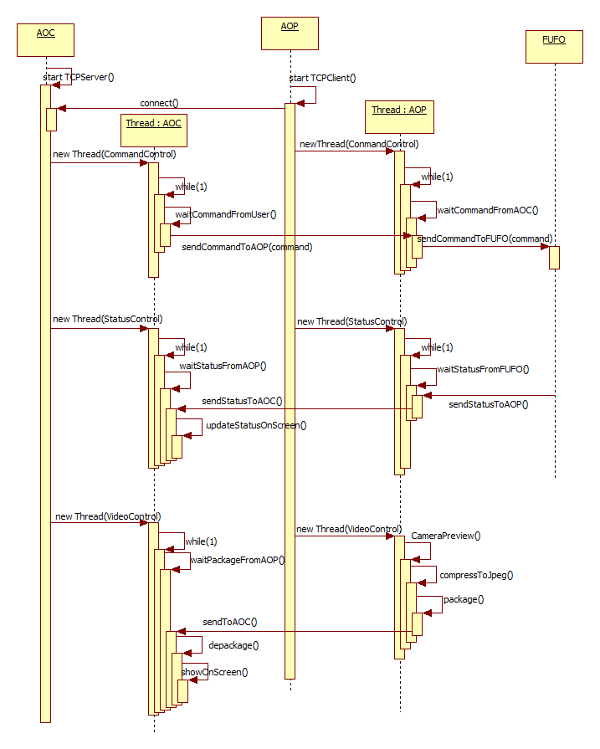
Figure 5: Sequence diagram for VP
[This section describes the system's decomposition into lightweight processes (single threads of control) and heavyweight processes (groupings of lightweight processes). Organize the section by groups of processes that communicate or interact. Describe the main modes of communication between processes, such as message passing, interrupts, and rendezvous.]

Deployment View
[This section describes one or more physical network (hardware) configurations on which the software is deployed and run. At a minimum for each configuration it should indicate the physical nodes (computers, CPUs) that execute the software, and their interconnections (bus, LAN, point-to-point, and so on.) Also include a mapping of the processes of the Process View onto the physical nodes.]

Implementation View

Overview

Layers
[For each layer, include a subsection with its name, an enumeration of the subsystems located in the layer, and a component diagram.]

Size and Performance
[A description of the major dimensioning characteristics of the software that impact the architecture, as well as the target performance constraints.]

Quality
[A description of how the software architecture contributes to all capabilities (other than functionality) of the system: extensibility, reliability, portability, and so on. If these characteristics have special significance, for example safety, security or privacy implications, they should be clearly delineated.]

Other Considerations
[This section provides a description of other approach/ solutions that were considered in selection process for the above architecture, i.e. a brief explanation of advantages and disadvantages of the selected architecture in comparison with others. It should be a clear answer to the question why the above architecture is selected for this system, not the others.]

